EXPERIMENT 12
Aim:To create an interactive diagram in Figma illustrating the evolution of mobile communication from 1G to 5G.
Procedure:
• Open Figma and create a new design file.
• Create a frame for the diagram.
• Draw five boxes representing 1G, 2G, 3G, 4G, and 5G.
• Add the main features of each generation.
• Add suitable icons and colors to each box.
• Connect the boxes using arrows to show the evolution.
• Use the Prototype option to make the diagram interactive.
OUTPUT:
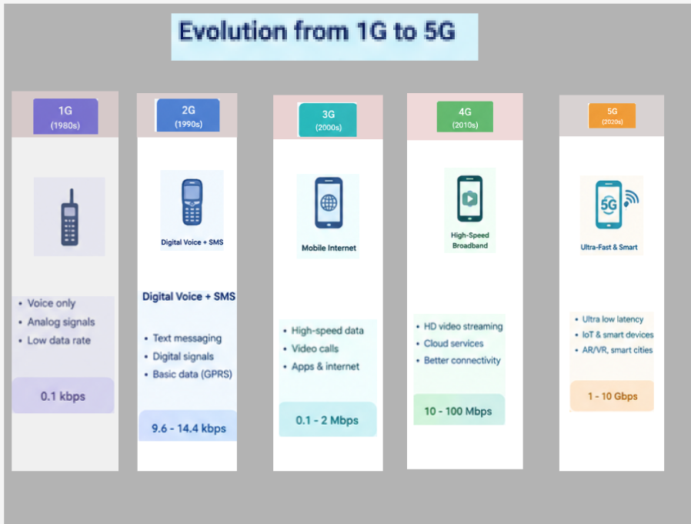

FIGMALINK: https://www.figma.com/design/ED1qcVpNfWi2Zuft4amJyZ/Untitled?node-id=63-63&t=zih8IyL283jodQsH-0
RESULT: The evolution of mobile communication from 1G to 5G was successfully illustrated in Figma using a simple interactive diagram.

